Customer Churn Prediction using Machine Learning
Data Analytics & Machine Learning Project
Technologies Used
Python | MySQL | Scikit-learn | Power BI
Prepared by
Sanjana K L
Project Description
This project predicts customer churn using machine learning techniques. Customer purchase data is analyzed to identify patterns that indicate whether a customer is likely to stop purchasing from the business. The project uses data processing, feature engineering, machine learning modeling, and interactive dashboards to provide insights into customer behavior.

Project Overview
Customer churn refers to customers who stop purchasing from a company. Identifying potential churn customers helps businesses take preventive actions to retain valuable customers.
In this project, customer purchase data from an e-commerce dataset is analyzed to predict churn behavior using machine learning.
The workflow includes:
• Data collection and loading
• Data cleaning and preprocessing
• Feature engineering
• Machine learning model training
• Model evaluation
• Data visualization using Power BI
The final output includes a trained churn prediction model and an interactive dashboard that provides insights into customer behavior and churn patterns.

Tools and Technologies Used
The following tools and technologies were used in this project:
Python:
Python was used for data processing, data analysis, and machine learning model development.
MySQL:
MySQL was used to store and manage structured customer transaction data.
Scikit-learn:
Scikit-learn was used to implement the machine learning model for predicting customer churn.
Pandas and NumPy:
These libraries were used for data manipulation and feature engineering.
Power BI:
Power BI was used to create an interactive dashboard for visualizing churn patterns and customer insights.
Matplotlib and Seaborn:
These libraries were used to create visualizations for data exploration and model evaluation.

Data Collection and Data Processing
The dataset used in this project contains information about customers, orders, and payments.
The following steps were performed during data preprocessing:
- Loading customer, order, and payment datasets using Python.
- Selecting relevant columns required for churn analysis.
- Merging multiple datasets to create a unified dataset.
- Converting date columns into datetime format.
- Aggregating customer-level features such as total orders and total spending.
After preprocessing, a structured dataset was created where each row represents a unique customer with features required for churn prediction.
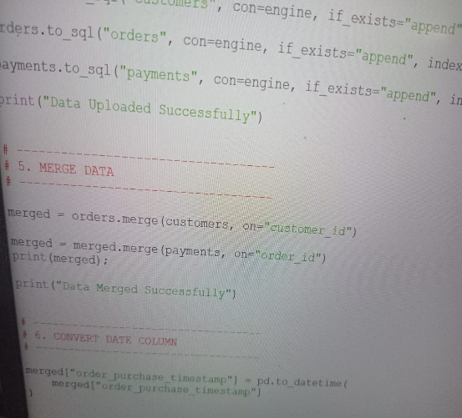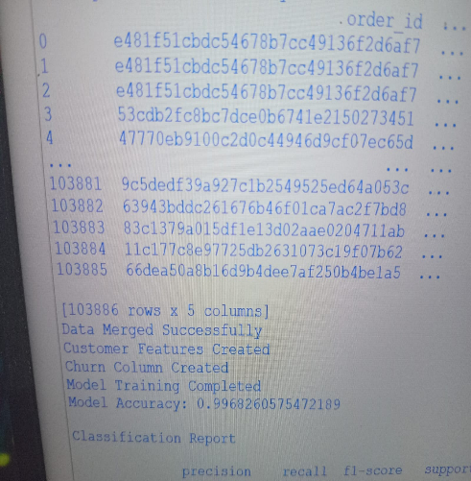

Machine Learning Model
A machine learning model was built to predict whether a customer is likely to churn.
The Logistic Regression algorithm was used for classification.
The model training process included the following steps:
- Splitting the dataset into training and testing sets.
- Scaling features using StandardScaler.
- Training the Logistic Regression model.
- Predicting churn for test data.
- Evaluating the model performance.
Model evaluation metrics used include:
Accuracy Score
Classification Report
Confusion Matrix
The trained model was saved using a pickle file for future predictions. 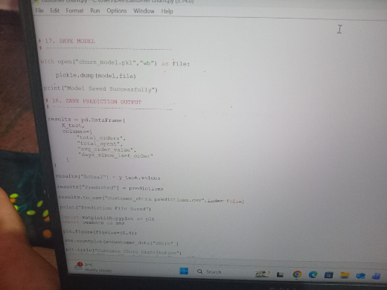 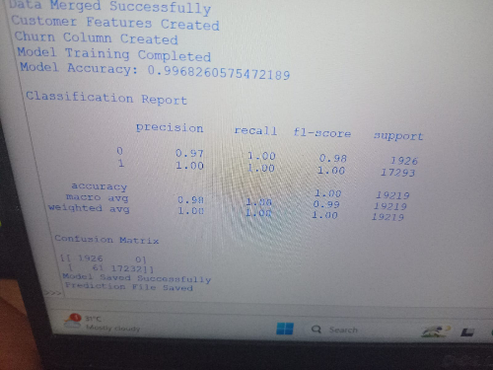
Customer Feature Engineering
Power BI Dashboard
- An interactive dashboard was developed using Power BI to visualize customer churn patterns and business insights.
- The dashboard includes the following visualizations:
- Customer Churn Distribution
Shows the proportion of active and churned customers.
- Revenue Lost from Churned Customers
Displays the revenue contribution from customers who stopped purchasing.
- Average Orders by Churn Status
Compares purchasing behavior between active and churned customers.
- Customer Recency vs Churn
Shows how inactivity affects churn probability.
- KPI Cards
Displays total customers, total revenue, and average order value
- These visualizations help stakeholders easily understand churn behavior and take strategic actions. 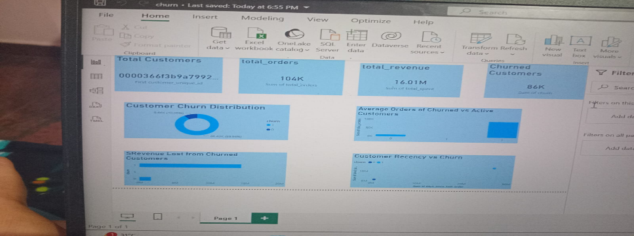
Customer Churn Analysis Dashboard

Conclusion
This project demonstrates how machine learning can be used to identify customers who are likely to churn.
By analyzing historical purchase behavior, businesses can detect patterns that indicate potential churn. The machine learning model helps predict churned customers, enabling companies to take proactive steps such as targeted promotions or personalized offers to retain valuable customers.
The Power BI dashboard provides a clear and interactive way to monitor customer behavior and business performance.
This project highlights the integration of data processing, machine learning, and data visualization to solve real-world business problems.

